Kendal AAC Committee Meeting
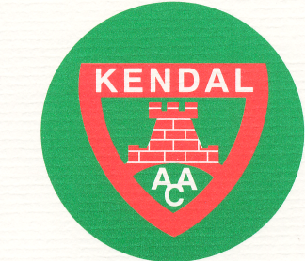
Monday 5th February 2018, 7.30pm
The Club Inn, Endmoor

Present:

Apologies:

Finance & Draw:

Membership:
- Applications / resignations / hardship requests
- Recruitment and induction of new Membership Secretary

Data Protection Policy (circuated):

Correspondence, website and social media:

News:
- Updates from XC, Road, Fells, Sportshall
- Track & Field 2018 – plans for team management
- Coaching Groups
- Club Championships
- Cumbria Update

Awards Evening:
- Organisation / organiser(s)
- Date and venue
Club Kit:

Incidents (confidential item as appropriate):

Minutes of last meeting:

Matters Arising not already on the agenda:

AOB:

Items for next meeting:

Date of next meeting: Mon 12th March 2018

