Kendal AAC Committee Meeting
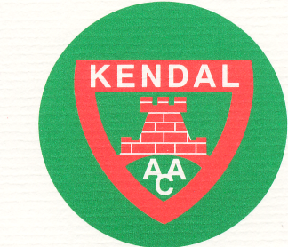
Monday 2nd September 2018, 7.30pm
The Club Inn, Endmoor

1. Present:

2. Apologies for absence:

3. Finance and Draw:

4. Membership:
- Applications / resignations / hardship requests
- New Membership Secretary

5. Correspondence / website / social media:

6. Updates (from a very successful summer!):
- Track & Field
- Fells and Road
- Awards Criteria meeting

7. Coaching Groups and Coaches update:

8. Facilities and Club Development:
- Club kit
- Facilities at QKS. What next? (Andy Rigg’s suggestion
9. Workshops / Information
- Injury Prevention Workshop date and venue
- Session for teenage athletes by Dr Rebecca Robinson date

10. Incidents (confidential item as appropriate):

11. Minutes of last meeting:

12. Actions and Matters Arising not already covered:

13. AOB:
- AGM

14. Items for next meeting:
- YDL

15. Date of next meeting: Monday 1st October

